INTRODUCTION PACK FOR
GENERAL PRACTICE NURSES
(GPNs) and Registered Nursing Associates (NAs)
ACROSS KENT & MEDWAY Primary Care

Version Draft 2.1
Version | Authors/Contributors | Date written | Date approved | Changes made
1.0 | KMPCTH GPN Leads |  | 2023 | Approved
Draft 2.1 | Sara-jane Kray (PCWDL)  Rachael Heathfield (GPN WL)  Sharon Lee (S-PCWDL)  Ann Humphreys (PCWDL)  Philly Adam (PCWDL)  Yvonne Wilson (PCWDL) |  | 2025 | Updated format  Slight changes to terms and links  Included NA into the document

Contents
Welcome to General Practice / Primary Care 5
Welcome to the NHS 6
The Sonnet Reports 7
Structure of NHS in England 7
Understanding Primary Care 9
Understanding Integrated Care System (ICS) and Integrated Care Boards (ICB) England 9
Health and Care Partnerships (Formerly known as Integrated Care Partnerships or ICPs) 10
Primary Care Networks (PCNs) 11
GP Federations 11
Community Education Facilitation Teams 11
Benefits of CEF 11
Training Hubs 11
Kent and Medway Primary Care Training Hub 12
GENERAL PRACTICE NURSE (GPN / NA) and REGISTERED NURSING ASSOCIATES Error! Bookmark not defined.
Introduction 14
Orientation 14
Future NHS 14
Indemnity insurance 14
NMC and Revalidation 15
Induction 15
Health and Wellbeing 15
Clinical practice meetings 15
Clinical supervision 15
Peer Mentoring 16
Protected Learning Time (PLT) 16
Appraisals 16
Greener NHS - 16
Preceptorship 17
Primary Care Induction Pathways 17
Practice Assessor and Practice Supervisor 18
CPD - Career opportunities and education 18
Learning Gradient 18
Practice Nurse Pathway 19
Functional skills 19
The Primary Care and General Practice Nursing Career and Core Capabilities Framework 19
Professional Nurse Advocate (PNA) 22
Research and Evidence-based Practice 22
The General Practice Nurse Education Network (GPN / NAEN) 22
National Association of Primary Care – CARE Programme 23
Simulation Training 23
The Queen’s Institute of Community Nursing 23
APPENDICES 24
Appendix 1: Suggested Elements for Orientation and Induction 24
Training 24
Resources and Guidelines 27
Websites 27
Professional subscription websites and magazines 27
EDI Resources 27
Appendix 2: Sample Induction Programme 28
Appendix 3 – Bibliography 35

Welcome to General Practice / Primary Care

Dear Colleague,
Welcome to your new role
We are delighted to welcome you to the Kent & Medway primary care team family!
Your decision to join us brings a wealth of experience and expertise that will greatly benefit our patients and our community.
As our new General Practice Nurse / Registered Nursing Associate, you will play an integral role in promoting health and wellness, providing high-quality care, and supporting our patients through their health journeys. Your skills and dedication are highly valued, and we are confident that you will make a significant impact on the lives of those we serve.
In your role, you will collaborate closely with the multidisciplinary team, including doctors, the nursing family, administrative staff, healthcare professionals, and other roles, to ensure a seamless and holistic approach to patient care. We believe that your contributions will enhance Primary Care and help us continue to deliver exceptional service.
We understand that starting a new position can be both exciting and daunting. Please know that the Kent & Medway Primary Care Training Hub and your employer are here to support you every step of the way. Should you have any questions or need assistance, do not hesitate to reach out to us, your colleagues and supervisor.
Once again, welcome to our family. We look forward to working with you and achieving great things together.
Warm regards,
Kent & Medway Primary Care Training Hub Team

Welcome to the NHS

Below are some general links and general information on being part of this organisation.

The NHS Constitution for England
‘The NHS belongs to the people.’

NHS Principles
- Health equality provision to all people of gender, race, disability, sexual orientation, religion or belief, marital status, or age.
- Free access to NHS services centred on clinical indication.
- Provision of high-quality health care and professionalism.
- Patient-centre care delivery.
- Collaborative work with other organisations in the best interest of the patients.
- Managing its resources fair and sustainable.
- Accountability to the public and the patients that it serves.

The Nolan principles of public services:
- Selflessness- working in the interest of the public.
- Integrity- working with honesty and avoiding external negative influences from other organisations or considering personal gains.
- Objectivity: Holders of public office must act and take decisions impartially, fairly and on merit, using the best evidence and without discrimination or bias.
- Accountability- being accountable for their actions and decisions.
- Openness- being transparent in all decision-making process and actions.
- Honesty- being truthful and not withholding relevant information.
- Leadership- ‘leading by example’ approach.

Equality, Diversity and Inclusion
The NHS promotes equal opportunities and welcomes everyone from all backgrounds and with any disabilities weather visible or not. As an employer, the NHS will take reasonable steps to support you to fulfil your role and progress in your professional career. Please make sure you discuss any issues or concerns with your line manager.
Achieving equality of health outcomes requires identification of barriers and biases, and targeted action to overcome specific inequalities, discrimination and marginalisation experienced by certain groups and individuals. The NHS is committed to improve equality, diversity and inclusion, and to enhance the sense of belonging for NHS staff to improve their experience. Therefore, being Culturally Competent is not only about respecting and appreciating the cultural contexts of patients’ lives. Neither is it a one-size-fits-all approach – it’s about understanding the way we deliver health care and respond to the needs of our diverse population.
NHS equality, diversity, and inclusion improvement plan
Additional EDI resources links are available in Appendix 1

The Sonnet Reports

Since 2021 the Sonnet reports have evidenced the worth of the General Practice Nurses (GPN / NAs) in Primary Care from their current capabilities to the future development of the NHS. The value of the nurses has been quantified through 8 factors seen below in Figure 1.

Fig. 1 Value drivers and enablers
Clifford, J., Barnes, K., Arora, R., and Raouf, S. (2021). Leading the Way: The role and value of nurses in general practice in England. London. Sonnet Impact.

The research has concluded that GPN / NAs have a unique role in General Practice providing holistic, evidenced-based practice care, often in a way that is both different and complementary to the wider multi-professional team. Networking formally and informally, within their team or the wider NHS, is utilised by GPN / NAs to improve outcomes for individual patients and strategically across systems of practice.

Reports can be found below:
Initial full report: Leading the Way: The role and value of nurses in general practice 2021
Summary: Nurses in General Practice: What they do and why they matter
Phase 3 full report: Leading the Way: The role and value of nurses in general practice in England 2024
Summary: Nurses in General Practice: Adding Value Across the NHS in England

Structure of NHS in England

The NHS Digital has created a useful pictogram explaining the structure of NHS England and the links between the major systems: Primary Care, Community Health, Secondary Care and Tertiary Care.
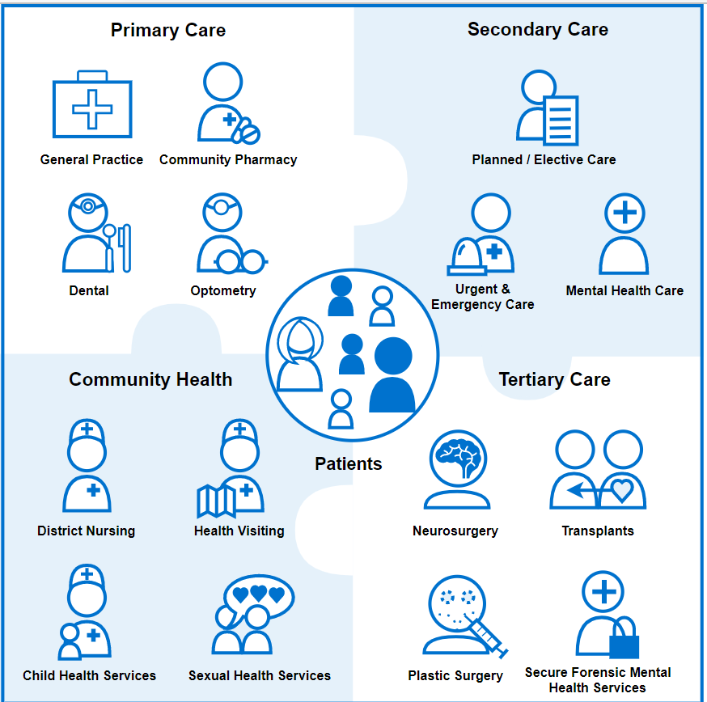
The healthcare ecosystem - NHS Digital

NHS England is a part of The Department of Health and Social Care (DHSC). The structure below shows the organisations’ rapport with the DHSC.
THE DEPARTMENT OF HEALTH AND SOCIAL CARE (DHSC)

Foreseeing the needs for health of the population and assist ministers outline policies needed to guide care.
Arm’s length bodies (DHSC’s agencies and partner organisations)

Organisation | Role | Website
NHS England | Providing quality health services. | https://www.england.nhs.uk/
Care Quality Commission (CQC) | Regulator of health and social care in England. | https://www.cqc.org.uk/
National Institute for Health and Care Excellence (NICE) | Providing evidence-based healthcare recommendations. | https://www.nice.org.uk/
UK Health Security Agency | Protecting people from the impact of infectious, chemical, biological, nuclear, and other health threats. | https://www.gov.uk/government/organisations/uk-health-security-agency
Health Research Authority | Protecting the health interests of the public. | https://www.hra.nhs.uk/
NHS blood and transplant | Encouraging blood, organs, and tissue donation to save lives. | https://www.nhsbt.nhs.uk/
Medicines and Healthcare products Regulatory Agency (MHRA) | Regulatory body for medicines, medical devices, and blood transfusions. | https://www.gov.uk/government/organisations/medicines-and-healthcare-products-regulatory-agency
NHS Business Service Authority | Manages finances for the delivery of national services. | https://www.nhsbsa.nhs.uk/
NHS Resolution | Providing expertise to resolve disputes fairly. | https://resolution.nhs.uk/
Human Fertilisation and Embryology Authority | UK fertility regulator | https://www.hfea.gov.uk/
Human Tissue Authority | Regulator of human tissues and organs. | https://www.hta.gov.uk/
NHS Counter Fraud Authority | Leading the fight against fraud, bribery, and corruption in the NHS. | https://cfa.nhs.uk/

Understanding Primary Care

Understanding Integrated Care System (ICS) and Integrated Care Boards (ICB) England

ICS is responsible for delivering health services for the local population. These consist of NHS bodies, local authorities and other relevant organisations joining together in a partnership. ICBs replaced Clinical Commissioning Groups (CCGs).

42 integrated care boards (ICBs) were established in July 2022 to facilitate the vision of care from the Health and Care Act 2022. Further details of Integrated care in your area are available via NHS England.

The King’s Fund illustrates this collaboration in the picture below.
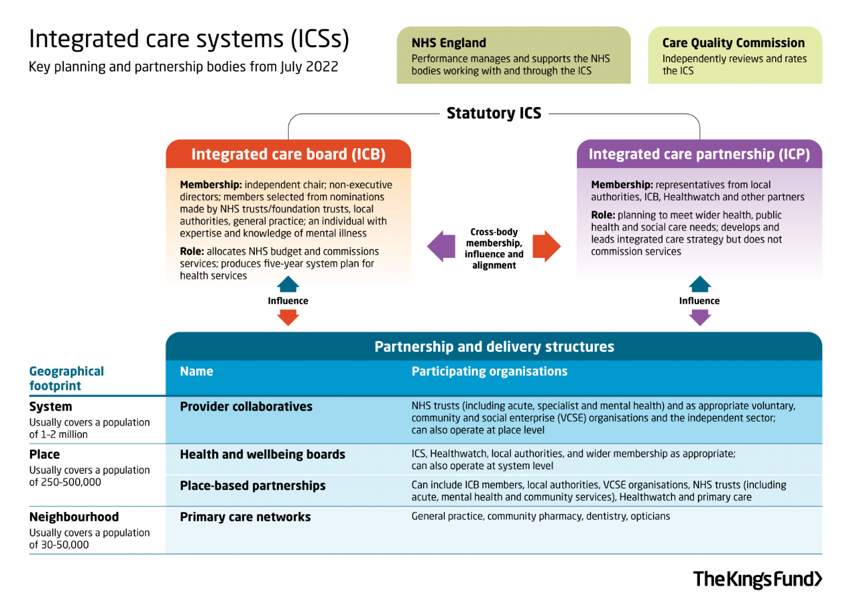
The NHS Kent and Medway Integrated Care Board consists of the Ashford Borough Council, Canterbury City Council, Dartford Borough Council, Dover District Council, Folkestone and Hythe District Council, Gravesham Borough Council, Maidstone Borough Council, Medway Council, Sevenoaks District Council, Swale Borough Council, Thanet District Council, Tonbridge and Malling Borough Council, Tunbridge Wells Borough Council.

Health and Care Partnerships (Formerly known as Integrated Care Partnerships or ICPs)
Health and care partnerships :: NHS Kent and Medway (HCPs) have the role of connecting all health providers in each area focusing on what services are most needed there, thus helping to reduce health inequalities.
Kent and Medway have four HCPs illustrated in the picture below. They consist of NHS organisations, local councils, Primary Care Networks (PCNs), Ambulance groups, social trusts, and other community services. These are designed to improve life expectancy for the population they are serving.
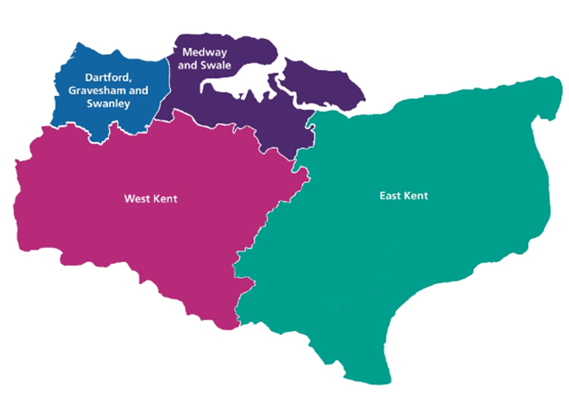

Primary Care Networks (PCNs)
Formed in 2019 consisting of local General Practice Settings who collaborate alongside the community teams, hospital, social care, pharmacies, mental health teams and voluntary sector to provide integrated care and services tailored for the needs of the local community. They help support a growing population with a more complex care need. There are 1250 PCNs in England and 43 in Kent and Medway.
Find your PCN: Primary care networks :: NHS Kent and Medway

GP Federations
Consists of groups of GP surgeries in partnership, which help with the delivery of health services closer to the patient’s home. They serve directly their own patients registered to these partner surgeries. There are 9 GP Federations in Kent and Medway – 6 in East Kent, 2 in North Kent and 1 in West Kent.

Community Education Facilitation Teams
The Role - The Community Education Facilitation (CEF) Teams will identify, lead and champion education and training needs for the multi-professional Primary Care workforce, to grow, support and sustain the development of skills, knowledge and expertise of the staff members now and for the future.
The initiative provides an infrastructure across PCNs that enables interprofessional placement of learning leaders, ensuring sustainability for the current and future workforce, whilst developing a great learning environment that enables best practice, quality placements and excellent patient experience. This helps grow our workforce and enables recruitment, retention and resilience through career development.
CEF Leads work alongside the KMPCTH to inform the needs and shape the support provided to their Primary Care Network (PCN).
There are 3 different CEF profiles:
- Medical CEF Lead
- Multi-professional Clinical CEF Lead
- Administrative Lead/Coordinator

Benefits of CEF
Facilitates the development of a learning environment within your PCN locality, enabling best practice, quality placements and excellent patient experience
Provides sustainability for your local current and future workforce
Assists with growing the workforce within your PCN
Enables staff recruitment, retention and resilience at a local level.

Further information is available KMPCTH Primary Care Roles - Community Education Facilitation (CEF)

Training Hubs
Training Hubs are organisations that provide support, education, and training to all staff in primary care. Each primary care organisation will have access to a training hub’s resources and guidance. NHS England (Former HEE) is providing the funding necessary to employ Training Hub staff in order to deliver the required level of education and guidance in any given area. ICS Training Hubs are accountable to NHS England and the ICS they serve. Some programmes that run through the training hubs can also be funded by the ICS to support their workforce meet the training needs required to serve their local population. Further information available at: Training Hubs and how they work

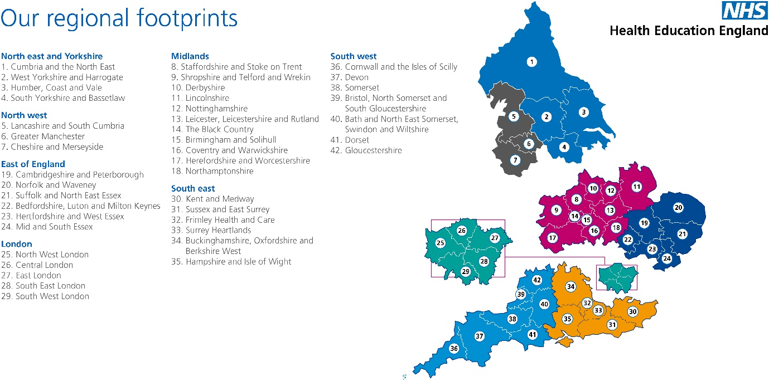

Kent and Medway Primary Care Training Hub

Kent and Medway Primary Care Training Hub was formed by the joining of the North, East and West Kent Training Hubs. This help provide a stronger team to support the professional development needs, the recruitment and retention of the workforce across Kent and Medway.
The Training Hub links NHS organisations, communities and education providers to produce a range of education opportunities to the primary care workforce. It can assist you in organising and funding education events for your support and advancement in your career.

Contact the team:
Website: https://kmpctraininghub.nhs.uk/ | 
Email: Kmicb.kmpcth@nhs.net

Twitter @KMPCTH

LinkedIn @Kentandmedwayprimarycaretraininghub

YouTube Kent and Medway Primary Care Training hub

Newsletter Primary Care News

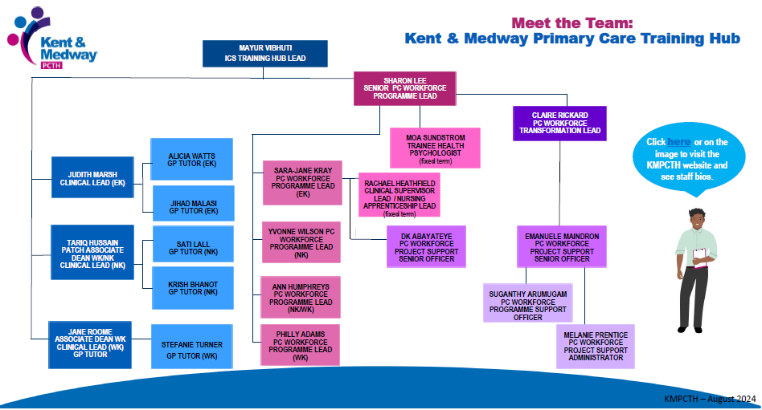

Introduction to the workplace
Newly qualified registered nurses (GPN), registered nursing associates (NA’s), those returning to practice and those joining practice nursing / Primary Care for the first time, can find the role a little daunting at first. They must become autonomous practitioners, taking on new skills and responsibilities which they may not be confident in.
To ensure the best possible start for a new GPN / NA, a quality orientation, induction and preceptorship programme is essential, as is education and ongoing continuing professional development (CPD).
An overview of this journey is displayed below. This document is structured using this journey and begins with providing an understanding of Primary care and its position in the NHS, exploring orientation, induction through to preceptorship and beyond.
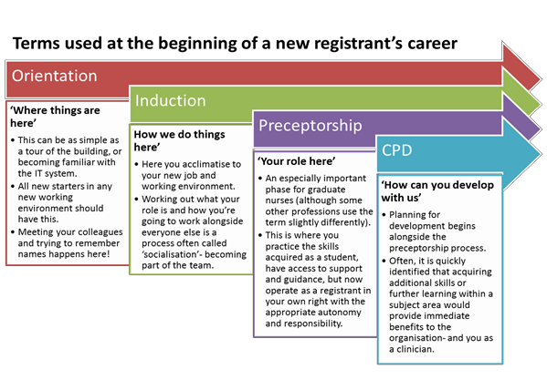

Orientation

Future NHS
FuturesNHS is an online platform from the NHS that helps connect the health and social care sector. The Kent and Medway Training Hub is working on uploading and updating relevant information relating to primary care on FutureNHS to provide a quick and accessible way to disseminate information and provide support and guidance. It is free to join.

Indemnity insurance
The Clinical Negligence Scheme for General Practice (CNSGP) provides cover for all incidents that happened after the 1^{st of} April 2019 and covers all staff members working in General Practice.
Please ensure your employer adds your details and most up to date scope of practice to ALL relevant documents, as scope changes may require additional / changes to the employer’s cover.
Am I covered under CNSGP?
There are certain limitations however to this scheme such as: private work, vaccinating patients with immunisations that are not covered on the NHS (i.e. against Rabies, BCG for travel, Yellow Fever, Meningitis ACWY for travel) or for occupational health purpose (i.e. against Hepatitis B); professional regulatory issues etc.
Some surgeries might have additional insurance, for instance from MDU (https://www.themdu.com/). Please speak to your employer to find out what is covered by that.
In addition, if you are a member of The Royal College of Nursing you are covered by the RCN indemnity scheme

The NMC has further guidance regarding nursing Professional indemnity.
Good Samaritan acts or emergency assistance - The NMC does not suggest the need for indemnity insurance in such cases if there is no legal duty to carry out these acts as this is not considered professional practice.
Good neighbour acts – This is described as helping the community in a professional capacity and the NMC suggest each clinician should use their professional judgement to establish if indemnity insurance is needed. The recommendation is to undertake insurance, especially if these acts are performed repeatedly even if unpaid.

NMC and Revalidation
The NMC Code of professional standards of practice and behaviour for nurses and midwives have been set by the Nursing and Midwifery Council (NMC). The Code contains a series of statements that taken together signify how good nursing and midwifery practice should be. It puts the interest of patients and service users first, is safe, effective, and promotes trust through professionalism.
This commitment to professional standards is fundamental to being part of a profession. The Code is central to the revalidation process and acts as a focus for professional reflection.
All nurses must undertake Continuous Professional Development (CPD) to enable them to revalidate with the NMC every three years. This must be at least 35 hours of learning activity relevant to the nurse’s practise. Nurses need to show how the learning activity has informed and influenced practice. Full details on how to revalidate are available at: NMC Revalidation
Activity
Download the NMC Code of Conduct to the desktop on your computer or print for easy access
Download NMC Revalidation documents either in paper form or to your computer desktop or print so you can start writing your reflective accounts and recording continual Professional development (CPD)

Induction

Health and Wellbeing
Being part of the Kent and Medway Primary Care area, gives you access to several Health and Wellbeing programmes and support. Below are some useful links for Mental, Physical and Financial Health:
Supporting Primary Care Staff | Kent & Medway Primary Care Hub (kmpctraininghub.nhs.uk)

Clinical practice meetings
Some organisations coordinate clinical meetings. These are a great opportunity to raise concerns regarding practice, discuss clinical case studies and even use this time to provide learning sessions on a specific clinical topic.

Clinical supervision
The role of clinical supervision is to provide GPN / NAs the prospect to reflect on their own practice, acknowledge areas for development, learning opportunities and discussing difficult situations in order to improve their practice. This will support your continuing professional development (CPD) and with the NMC revalidation process. It is also a requirement to meet the CQC (Care Quality Commissioning) good standards of practice (GP mythbuster 26: General practice nurses - Care Quality Commission (cqc.org.uk)).

Peer Mentoring
The KMPCTH peer mentoring fully funded service is provided as individual sessions between you and a Mentor. The aim of Peer Mentoring is to provide career support, personal or professional concerns to the multidisciplinary team working in Primary care. All the Mentors are experienced professionals that understand the pressure that exist currently in Primary Care.
Please contact kmicb.kmpcthmentoring@nhs.net if you think you might benefit from Peer Mentoring.

Protected Learning Time (PLT)
Protected Learning Time is an opportunity for practice staff to keep up to date with their professional development needs and learning. Every year there are 9 sessions – 3 employer led, 3 PCN led and 3 KMPCTH led. You should receive an email with information of when PLT afternoons are and what is on the agenda from your Community Education Facilitation Team.

Appraisals
It is important that all staff in general practice undertake annual appraisals. This ideally should be done by your line manager, likely lead nurse. This is an excellent opportunity to reflect on your practice and identify areas that you have done well and areas of improvement. Appraisals are a good time to discuss further trainings required to improve patient care and safety.
Kent, Surrey and Sussex Primary Care Training Hubs have developed guidance to help you get the best from your appraisal.

Greener NHS -
Climate change poses a major threat to our planet. In view of these changes, NHS has developed ‘Greener NHS programme to work with clinicians to build on the great work being done by trusts across the country, sharing ideas on how to reduce the impact on public health and the environment, save money and reach net carbon zero.

Preceptorship

Primary Care Induction Pathways
Option 1  New-to-practice programme (NTPP) | Option 2  Preceptorship only | Option 3 - Gold standard  (Recommended)  NTPP and Preceptorship
New-to-practice programme (NTPP)  NTPP is a national initiative intended to support newly qualified GPs, Nurses and Nursing Associates to successfully start their career in Primary Care. The duration of this programme is 13 months and is based on leadership, coaching, mentoring, and additional learning relevant for the GPN / NA role.  Peer Group Learning Sets are an integral part of the NTPP to encourage more focused learning, support and the grounded contextual understanding that comes from working in primary care. They aim to provide the Nurse /NA with:  Knowledge sharing and emotional support - providing a protected, safe space to ask questions, discuss concerns and raise issues or work through problems with peers who understand the unique stresses of the profession.  Opportunities for continued professional development, reflection and feedback.  A sustainable network of peers outside of their place of work, reducing isolation and increasing your connection to others with a shared experience.  A self-managing peer group that continues to support and provide learning experiences beyond the programme.  Have a discussion with your line manager before applying. Details can be found: KMPCTH NTPP | National preceptorship framework for nursing  National preceptorship framework for nursing  For newly qualified practitioners or new practitioners to General Practice, this preceptorship document will be a structured start to develop a professional portfolio and embed knowledge into practice. Keeping a portfolio also offers considerable opportunity for reflection on ongoing development and is a requirement for NMC revalidation.  The preceptorship programme should ideally last 1 year, but it can be longer depending on the needs of the individual GPN / NA.  You should be allocated a preceptor that will help you develop your confidence and help to identify strengths and areas of opportunity for future development within the first few days in practice.  Protected time should be allocated with your preceptor to set objectives and identify learning needs.  NMC provides further guidance on preceptorship:  NMC: Principles of preceptorship | The new-to-practice  programme (NTPP) used in conjunction with a preceptorship period and support in practice is the gold standard. This will give the GPN / NA the opportunity to gain a better understanding of how Primary Care works and be part of the extended team.  This pathway will also encourage autonomy, confidence and a better learning/working environment to help the GPN / NA achieve high standards in patient care.

Practice Assessor and Practice Supervisor
Part of your role as GPN / NA is to provide support and supervision to the nursing students in the clinical environment. Supervision of nursing students can only be done when relevant knowledge and experience has been achieved in practice by the GPN / NA. Please speak to your preceptor/line manager and/or the Kent and Medway Training Hub for more information.
NMC have highlighted the NMC Standards for student supervision and assessment and the Practice supervision Guides
Training courses are available via CCCU Practice Assessor/Supervisor Workshops

CPD - Career opportunities and education

Learning Gradient

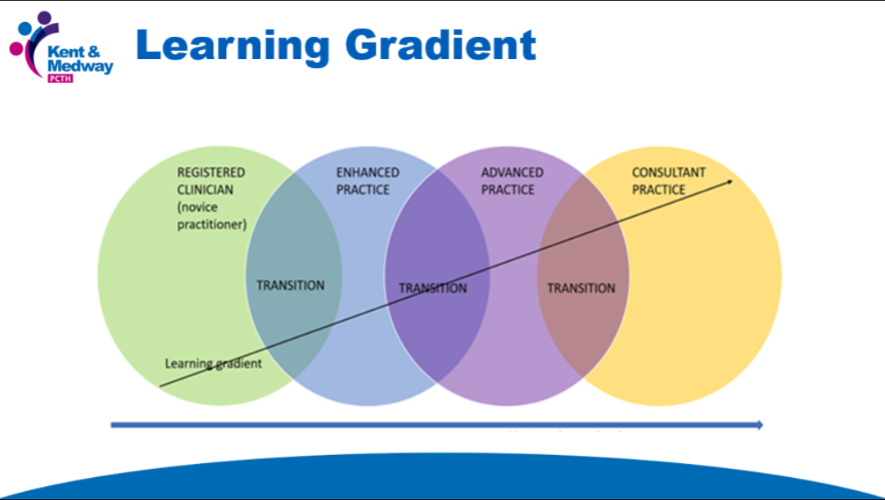
The picture below gives a brief view of requirements for each of the career pathways. If you are interested and want to know more information, please contact the Kent and Medway Training Hub.

Practice Nurse Pathway
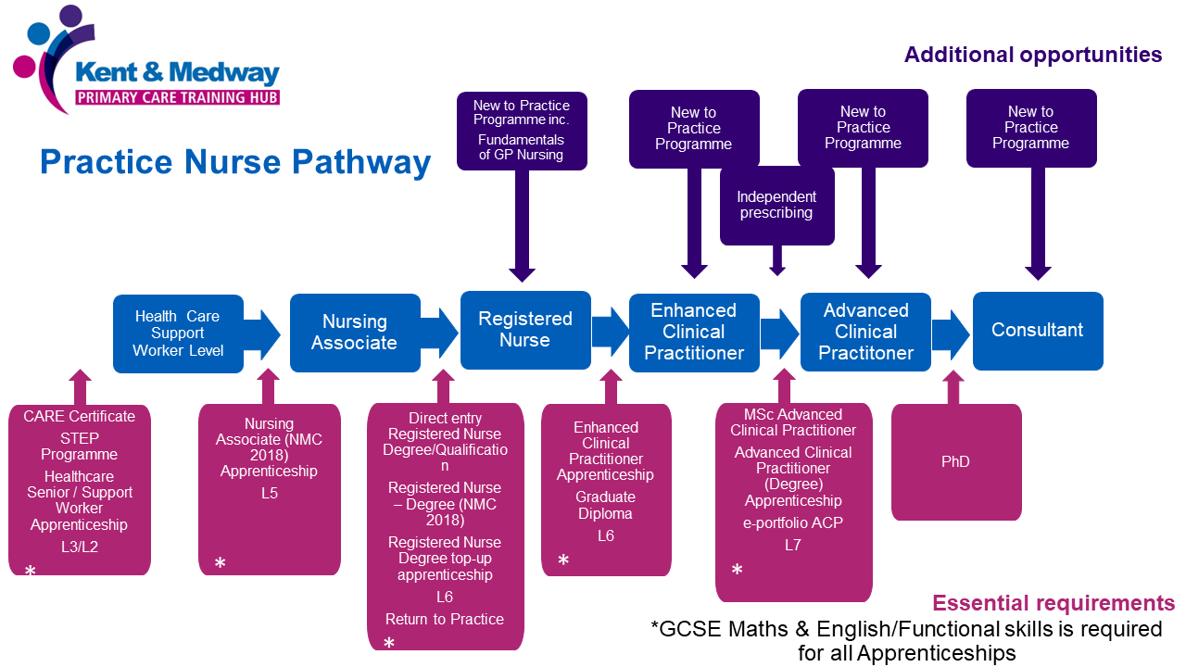

Functional skills
Functional Skills English and Maths are requested for all apprenticeship and career progression as identified above. This helps people of all education levels to access the necessary skills to improve reading, writing and communications, allow a better understanding of numbers and mathematical concepts, and are one of the most popular qualifications taken by adult learners. Please contact the KMPCTH for further information via Kmicb.kmpcth@nhs.net

The Primary Care and General Practice Nursing Career and Core Capabilities Framework

Primary Care and General Practice Nursing plays an integral part of the multi-professional team. This framework will help promote and support nurses, employers, workforce planners and people to understand the wealth of knowledge, skills, and attributes that the nursing profession can provide in primary care/general practice, to meet the needs of the population. The framework is made up of 2 components:
- A career framework component
- A core capabilities framework component
Career framework component can help support the sustainability and growth of the workforce in this area and facilitate the movement of staff to work within primary care services, as well as providing a career structure for staff working in this area. The framework consists of 6 levels of practice:
- Support Work Level Practice
- Nursing Associate Level/Assistant Practitioner Level Practice
- Registered Nurse Level Practice
- Registered Nurse: Enhanced Level Practice
- Registered Nurse: Advanced Level Practice
- Registered Nurse: Consultant Level Practice
The career framework focuses on articulating levels of practice as opposed to defining roles/jobs, it is possible that certain roles/jobs could cut across more than one of the identified levels within the career framework.
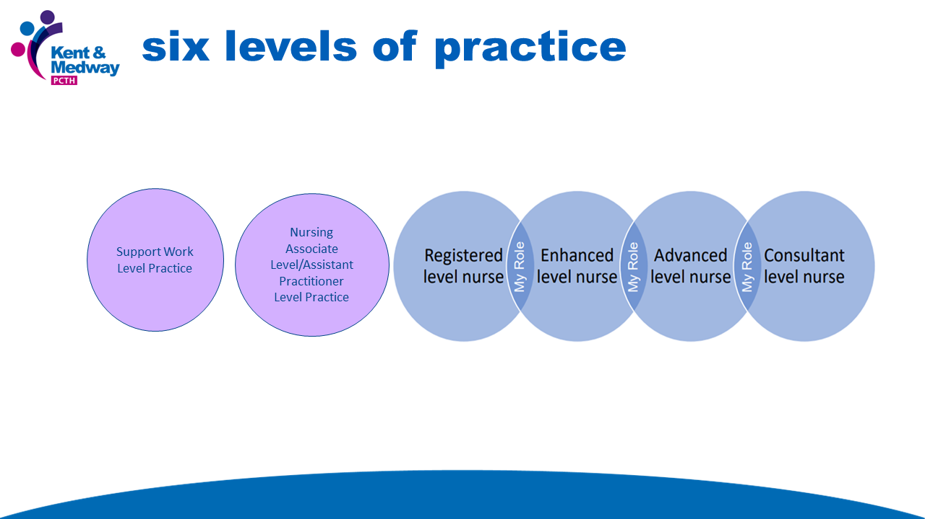
Information within the Career Framework includes:
- Level
- Level Descriptor
- Indicative Requirements to work at specified level
- Indicative Roles

The Core Capabilities Framework articulates such capabilities necessary for safe and effective care. These are written at a relatively ‘high-level’ and allow employers to contextualise the capabilities appropriately to suit the environment of care in which their service operates and the many job roles they utilise.
The core capabilities within this document are broken down into four domains:
Domain A. Personalised collaborative working and health promotion.
Domain B. Assessment, investigations, and diagnosis
Domain C. Condition management and treatment
Domain D. Leadership and management, education, and research.

Within the domains there are a total of 14 capabilities:
Domain A:
- Communication and consultation skills
- Practising holistically to personalise care and promote public and person health
- Working with colleagues and in teams
- Maintaining an ethical approach and fitness to practice
Domain B:
- Information gathering and interpretation
- Clinical examination and procedural skills
- Making a diagnosis
Domain C:
- Clinical management
- Managing Medical Complexity
- Prescribing treatment, administering drugs/medication, pharmacotherapy
Domain D:
- Leadership, management, and organisation
- Education and development
- Research and evidence-based practice
- Strategic Management
The capabilities (i.e., skills, knowledge, and behaviours) described in the framework are defined at 3 tiers.
The framework is incremental building from Tier 1 to Tier 3 (e.g., Tier 3 assumes that people possess the capabilities at preceding tiers (to minimise unnecessary repetition). Each tier articulates the minimum and core capability to be expected as opposed to the maximum.
The advantage in articulating the core capabilities across 3 tiers is to give employers/practitioners maximum flexibility in taking a job/role and working through all 14 capabilities and identifying which tier of practice is required in which context.
Capabilities are defined as attributes (skills, knowledge, and behaviours) which individuals bring to the workplace. This includes the ability to be competent, and to:
- manage change
- be flexible
- deal with situations which may be complex or unpredictable and,
- continue to improve performance.
In practice, the terms ‘capability’ and ‘competence’ and are both widely used in educational and workforce development literature, and they have often been used interchangeably, with little clear distinction between the two. Both capability and competence:
- are about ‘what people can do’
- describe knowledge, skills, and behaviours
- can be the outcome of education, training, or experience.
However, for the purpose of the framework the term ‘Capabilities’ describes the ability to be competent and to work effectively in situations which may require flexibility and creativity.
Key Points:
Supervisory expectations
At a Registered Nurse level practice and above, it is expected that you have responsibility for supervision of staff or/and indicative requirement of the role is training and Appropriate Practice Supervisor/Assessor Status. To meet Tier 2 of Capability 12: Education and Development you MUST be able to support practice development by acting as a mentor and/or clinical assessor as appropriate. Additionally, as an Advanced Practitioner the Indicative requirement to work at this level is the expectation that you have also completed the NHS England FCP - Advanced Practice Roadmap Supervision & Verification Training
Independent Prescribing (IP)
Within the Career Framework IP is an indicative requirement for those working at Registered Nurse: Enhanced Level Practice and above. IP is covered by Capability 10: Prescribing treatment, administering drugs/medication, pharmacotherapy Tier 3.
N.B. When working at enhanced level the nurse will likely have some advanced level capabilities but essentially not enough to meet the advanced level requirements. For enhanced level they may be prescribers with a scope of prescribing around specific long-term conditions as an example and able to meet tier 3 requirements.

Professional Nurse Advocate (PNA)
The Professional Nurse Advocate (PNA) Training Programme is an accredited virtual Level 7 clinical professional development programme for registered nurses to equip them with the skills and knowledge to support the mental health and wellbeing of fellow colleagues and improvement of patient care.
The training will focus on the four functions of the Advocating for Education and Quality and Improvement (A-Equip) Model The four functions of the A-Equip Model are as follows.
- Clinical Supervision (Restorative)
- Monitoring, Evaluation and Quality Control (Normative)
- Personal Action for Quality Improvement
- Education and Development (Formative)
The Professional Nurse Advocate (PNA) Training Programme will run for 10 days, but the delivery will vary over weeks or months. The mode of assessment will be dependent upon the university, these can vary from: Short Essays, Poster Presentations and Competency Portfolios.
The differing of assessment modes is due to many factors, some of which are uncontrollable.
- Academic requirements are set by the Education Board per university
- Assessments are aligned with the module credits worth; the variation is a result of different credit bearings for the programme per university; the module credit worth varies between 15 – 30 credits.
It is expected that as soon as you start the PNA Training Programme, you will start to; support your fellow colleagues, facilitate restorative clinical supervision in practise, and lead and deliver quality improvement initiatives in response to the service demands and the ongoing changing patient requirements.
Further information can be found on our PNA webpage: NHS England >Professional nurse advocate

Research and Evidence-based Practice
All NHS staff have access to the NHS library for free.
Make sure you create an OpenAthens account first via the Knowledge and Library Hub.
There is a range of resources – all available free from your NHS knowledge and library services, for anyone working or studying in England via Library resources for nursing and midwifery

Additionally, there are many wonderful opportunities for career development in Kent ad Medway. Below there is an overview illustration of what a career development would look like. Although, this takes you all the way to Consultant Level Practice, all levels are just as important for our patients’ care.

The General Practice Nurse Education Network (GPN / NAEN)
The General Practice Nurse Education Network was developed by the Queen’s Nursing Institute to support GPN / NAs. The website provides information on how to become a GPN / NA and additional information to help with your practice.

National Association of Primary Care – CARE Programme

CARE is a learning and development programme that empowers and activates primary health and care professionals to lead change within their practice, primary care network or neighbourhood. The programme equips individuals through training and support to look at their approach including personal impact, their leadership skills and the application of population health improvement approaches to develop or change local services with a measurable difference.

Simulation Training
Simulation offers a unique way of learning, and the sessions are designed to enable participants to learn about the clinical management of the scenario and the non-technical and human factors around teamwork, communication, and leadership in a safe environment. The practice might arrange this type of training.

The Queen’s Institute of Community Nursing
The Queen’s Institute of Community Nursing is a charity that leads in excellence and supports nurses to develop and improve the care for the patients in nursing homes and community. If you are interested in being part of The Queen’s Nursing Institute, please visit their website.

APPENDICES

Appendix 1: Suggested Elements for Orientation and Induction
Orientation should provide all the information that a new employee needs, without overwhelming or diverting them from the essential process of integrating into the existing team.
Orientation should include
Tour of the building/site(s)  Fire exits and policy | Health and safety requirements  Role responsibilities | Meeting other members of the team | Contracts and terms of employment
Administration and management
How primary care is structured and funded | How to use the practice IT applications | Electronic record keeping procedures and processes | Audit and information collation/analysis
Location and familiarisation of Practice Policies:  - Infection control TOOLKIT  - Policy for sharps injuries and accident book  - Cold chain policy  - Child safeguarding  - Adult safeguarding  - GDPR  - Fire and safety  - Other: | Emergency procedures | Equipment ordering and stock management | Care Quality Commission (CQC) regulations and outcomes
Quality Outcomes Framework (QOF) – Introduction to and how to use for service improvement/redesign
Clinical Management
Accountability and responsibilities within the role and the practice | Legal, ethical, and professional issues including accountability and delegation | Using local clinical guidelines, protocols, directions, and directives including prescribing and medicines management | Areas of clinical responsibility (i.e., health promotion, screening and immunisations, wound management, long term conditions management (and the required training to support, develop and extend these areas further)

Training
Education and training are facilitated by mixed providers.
- Core training is provided by Invicta Health Learning https://invictahealth.co.uk/provide/invicta-health-learning/. You will need to create an account to allow you access to book courses but please check with your line manager before you do that.
- Enhanced training and education is supported by the Kent and Medway Training Hub. We can discuss education and career development with you and support with funding for appropriate training and education.
- E-Learning courses are available via e-Learning for Health There are several relevant modules to help with your practice including Health Promotion and Chronic Disease Management.

All areas of professional practice require regular updating. This includes but is not limited to, updating of immunisation knowledge which should take place at least annually and when there are changes to the vaccination programme. The subjects that should be included in updates are specified in the minimum standards and core curriculum for immunisation training document. Sample-takers for the cervical screening programme should attend three yearly updating.
There is an annual budget for each Practice Nurse (approx. £333) to supplement your training needs. Please contact your Community Education Facilitator (CEF) to discuss your options. The CEF can also help you find the required training you need.
To find out who your CEF is contact the Kent and Medway Training HUB.
Statutory Training
Basic Life Support & AED |  | Update annually
Conflict Resolution |  | Update every 3 years
Control of Substances Hazardous to Health (COSHH) |  | Update every 3 years
Deprivation of Liberty (DoLs) |  | Update every 3 years
Equality, Diversity and Human Rights |  | Update every 3 years
Female Genital Mutilation (FGM) |  | Once
Fire Safety: Level 1 or Fire Warden Training |  | Update annually
Health, Safety and Welfare |  | Update annually
Infection Prevention Control and Waste Management Level 2 |  | Update annually
Moving and Handling |  | Update every 3 years
Mental Capacity Act (MCA) |  | Update every 3 years
Safeguarding Children (Level 2 or 3) |  | Update every 3 years
Safeguarding Vulnerable Adults (Level 2 or 3) |  | Update every 3 years
Preventing Radicalisation |  | Update every 3 years
Chaperone |  | Once
Sepsis |  | Update every 3 years
Data security Awareness: Level 1 (Information Governance) |  | Update annually
Additional training for GPN / NAs:

Cervical Cytology and HPV | Initial course and 3 yearly updates. Cervical Screening Programme - Berkshire & Surrey Pathology Services (berkshireandsurreypathologyservices.nhs.uk)  NEPSEC – North of England Pathology and Screening Education Centre
Childhood Immunisations | Initial course and annual updates.
Travel Immunisations | Initial course and 3 yearly updates. https://travelhealthpro.org.uk/
Contraception | Initial course. Update as required.  FSRH has good resources, guidelines and additional training.  https://www.fsrh.org/education-and-training/
Respiratory training  (Includes Asthma and COPD) | Initial course. Update as required.
Spirometry | Initial course accredited by ARTP. 3 yearly updates. https://www.artp.org.uk/Spirometry-Overview
Diabetes | https://pitstopdiabetes.co.uk/courses/course/prepitstop-3-day-course-diabetes/
Ear care | Initial course and 3 yearly updates.
Wound management | Initial course. Update as required.
Other:

Primary Care
Clinical Support | Your employer should help you to identify a preceptor who can facilitate your learning during your period of induction and a mentor/buddy who can support this learning.  Clinical supervision should be provided at regular intervals; however, you can ask your line manager for it when you feel it is needed.  Appraisals are mandatory and should be provided annually. This is a good opportunity to discuss further personal and educational developmental needs, acknowledge your progression/achievements and even discuss salary.
Communications | Do ensure your employer sets up an NHS email address for you as soon as possible as most correspondence is sent to Practice Nurses this way.
Computer access | Your employer will give you your own Microsoft login and clinical system login (Emis, Vision, System One) and other additional access that you require.  Register for cytology access (Open Exeter or Berkshire & Surrey Pathology Services- https://cstd.asph.nhs.uk/admin/index.php?openair=stm ); Immform Intranet Portal - Logon (phe.gov.uk)to be able to order vaccines; INR Star INRstar Login - INRstar Help.
Learning and  Development | Log on to the GP Staff Training Team training Website via Invicta Health Learning Pool and set up a username and password to access training: https://invictahealth.co.uk/provide/invicta-health-learning/and elearning for healthcare: Home.  Protective Learning Time (PLT) is available to all clinical staff to address their own learning and professional development needs.
Professional  Registration/ bodies | Register on NMC (Nursing and Midwifery Council) online for support and the code http://www.nmc.org.uk/standards/code and revalidation information http://revalidation.nmc.org.uk/.  You can also join the RCN (Royal College of Nursing) - union and professional body for nursing. https://www.rcn.org.uk/join-the-rcn/Join

Working in a small team necessitates sharing of goals and aspirations. The contents of this pack facilitate discussion with your employer or Clinical Lead GP(s) and nurse colleagues.
We hope you enjoy your new post, and you will access all available opportunities to enhance your practice. Please contact your Primary Care Workforce Programme Leads or GPN / NA Leads if we can be of any help to you.

Resources and Guidelines

Websites
National Institute for Health and Care Excellent - Clinical Knowledge Summaries (NICE CKS) | https://cks.nice.org.uk/
Global initiative for chronic obstructive lung disease (GOLD) | https://goldcopd.org/
British Thoracic Society BTS SIGN | https://www.brit-thoracic.org.uk/quality-improvement/guidelines/asthma/
Asthma + Lung UK | https://www.asthma.org.uk/
Diabetes UK | https://www.diabetes.org.uk/
T.R.E.N.D Diabetes | https://trenddiabetes.online/
Gateway C Cancer Education | https://www.gatewayc.org.uk/
Macmillan | https://learnzone.org.uk/
Jo’s cervical cancer trust | https://www.jostrust.org.uk/
Royal College of Nursing | RCN Learn
Nursing and Midwifery Council (NMC) | Our Equality, Diversity and Inclusion (EDI) Plan

Professional subscription websites and magazines
Practice Nursing UK | https://practicenursing.co.uk/
RCN | http://www.rcn.org.uk/development/practice/cpd_online_learning
Londonwide LMCs – Training for General Practice Nurses | http://www.generalpracticenurse.org.uk/
NB Medical | https://www.nbmedical.com/webinars/speciality/nurse
Red Whale | https://www.redwhale.co.uk/

EDI Resources
NHS England >> The Equality and Health Inequalities Hub
NHS England » Support for our diverse colleagues
NHS England » Civility and Respect
NHS England South East Region - Equality, Diversity & Inclusion Skills Development Sessions | Kent & Medway Primary Care Training Hub
EDI Videos | Kent & Medway Primary Care Training Hub
EDI Documents | Kent & Medway Primary Care Training Hub
Diversity eBook Collection | Knowledge and Library Services
Cultural Competence and Cultural Safety - elearning for healthcare
eLearning programme tackles England’s health inequalities - elearning for healthcare

Appendix 2: Sample Induction Programme

Name:
Employer:
Date of commencement in post:
AIM
- The purpose of this programme is to offer a framework for which the professional and clinical needs of new nurses in post can be identified and agreed.
- The programme should be discussed with the GPN / NA, experienced preceptor (or Practice Nurse Lead) and your employer
- Training and supervision should then be designed, planned and implemented where gaps in knowledge and skills are identified.
This document should be retained for future discussion as part of any appraisal outcomes of the induction programme.
ORGANISATION
Learning Outcome:

The new GPN / NA will have identified lead roles, responsibilities and accessibility of colleagues and resources available to support clinical practice. Estimated time to complete is 6 hours
DEVELOP LINKS WITH: | DETAILS |  |  | DATE COMPLETED
In-house members of the team:

GPs

Other members of the Practice Nursing Team including Healthcare Assistants

Other clinical roles ACP/ANP/FCP/AHPs

Employer – to include health and safety issues, fire procedures and general management. Job description, terms and conditions of employment, annual leave entitlement and understanding of the processes.

Arrangements for off-duty requests, reporting sickness etc.

Reception area to include reception staff introductions,

Policies, procedures, appointment system and telephone enquiries.

Administration staff

Other staff attached to the practice e.g., midwife, counsellor, CPN.

Introduction to the computer system.

External Relevant Agencies

ICB Team, CEF Leads

Local pharmacies

Others
Reflection and comments:
GPN / NA Name: |  |  | Signature: |  | Date:
Employer / Lead Nurse Name: |  |  | Signature: |  | Date:
CLINICAL PRACTICE
Learning outcome:

The GPN / NA will have identified areas of responsibility for training needs, resources and planned the process of achieving competency.
These activities will be included within the supervised practice hours and should be undertaken with the preceptor/lead GPN / NA. The aim is for both the preceptor/lead GPN / NA to discuss the management of the activities below and help the new GPN / NA to identify her role.
Statutory Training | Initial Training Date: |  |  | Update Due Date:
Basic Life Support & AED
Conflict Resolution
Control of Substances Hazardous to Health (COSHH)
Deprivation of Liberty (DoLs)
Equality, Diversity and Human Rights
Female Genital Mutilation (FGM)
Fire Safety: Level 1 or Fire Warden Training
Health, Safety and Welfare
Infection Prevention Control and Waste Management Level 2
Moving and Handling
Mental Capacity Act (MCA)
Safeguarding Children (Level 2 or 3)
Safeguarding
Vulnerable Adults (Level 2 or 3)
Autism
Learning disability
Oliver McGowan
Preventing
Radicalisation
Chaperone
Sepsis
Data security Awareness: Level 1
(Information Governance)
Additional training for GPN / NAs:
New to Practice
Programme – including Fundamentals of
General Practice
Practice Assessor /
Supervisor
Cervical Cytology and HPV
Childhood
Immunisations
Anaphylaxis
Travel Immunisations
Contraception
Respiratory training
(Including Asthma and COPD)
Spirometry
Diabetes
Ear care
Wound management
NHS health checks
Anticoagulation
Shared decision making
Unconscious bias
Covid 19
Influenza immunisation
Cancer Awareness
CVD and Hypertension
Dementia Awareness
ECG
In house training
Ambulatory ECG
Ambulatory BP
Reflection and comments:
GPN / NA name: |  | Signature: |  |  |  | Date:
Employer / Lead Nurse Name: |  | Signature: |  |  |  | Date:
MANAGEMENT OF WORKPLACE
Learning Outcome:
The GPN / NA will have considered management issues related to safe clinical practice and discussed the process of organisation:
Item | Discussion with Lead GPN / NA/Employer |  |  | Action plan
Ordering
equipment/supplies
Resuscitation equipment – to include availability, maintenance and access to medical help
Nebuliser –Availability and maintenance
Record keeping –
computer and manual recording
Health & Safety
Uniform & protective clothing
Clinical waste disposal
Infection control
Accident book
Understanding of
personal, personnel and building security
Fire safety & location of alarms, emergency equipment & fire exits
Ordering & storage of vaccines and cold chain procedures
Policies Protocols and procedures
Awareness of CQC requirements
Awareness of clinical governance
Location of online polices
Location and understanding of PGDs and PSDs
Reflection and comments:
GPN / NA name: |  | Signature: |  |  |  | Date:
Employer / Lead Nurse Name: |  | Signature: |  |  |  | Date:
PROFESSIONAL DEVELOPMENT
Learning outcomes
The GPN / NA will have resources to provide his/her own professional support.
Required | Identify contacts |  |  | Date obtained
Professional
organisational
membership for
professional indemnity
Clinical supervision (with whom)
Discussion if appropriate re- accountability &
appraisal
Educational / training needs
Miscellaneous

Reflection and comments:
GPN / NA name: |  | Signature: |  |  |  | Date:
Employer / Lead Nurse Name: |  | Signature: |  |  |  | Date:

Appendix 3 – Bibliography

Cabinet Office (2022) Public bodies, GOV.UK. Available at: https://www.gov.uk/guidance/public-bodies-reform#:~:text=An%20arm's%2Dlength%20body%20(%20ALBs,classified%20by%20the%20Cabinet%20Office. (Accessed: January 23, 2023)
Charles, A. (2022) Integrated Care Systems explained, The King's Fund. Available at: https://www.kingsfund.org.uk/publications/integrated-care-systems-explained (Accessed: January 23, 2023).
Clifford, J., Barnes, K., Arora, R., and Raouf, S. (2021). Leading the Way: The role and value of nurses in general practice in England. London. Sonnet Impact.
Cox, D. and Wray, J. (2022) National preceptorship framework for nursing, NHS choices. NHS. Available at: https://www.england.nhs.uk/long-read/national-preceptorship-framework-for-nursing/ (Accessed: January 23, 2023).
Department of Health and Social Care (2021) The NHS Constitution for England, GOV.UK. Available at: https://www.gov.uk/government/publications/the-nhs-constitution-for-england/the-nhs-constitution-for-england (Accessed: January 23, 2023).
Diversity eBook Collection | Knowledge and Library Services
Good Governance Institute (2020) Helping to create a fairer, Better World: Good governance, Good Governance Institute. Available at: https://www.good-governance.org.uk/publications/insights/the-nolan-principles (Accessed: January 23, 2023).
Health Education England (2022) Training Hubs and how they work, NHS choices. NHS. Available at: https://www.hee.nhs.uk/our-work/primary-care/training-hubs/training-hubs-how-they-work (Accessed: January 23, 2023).
Health Education England (2022) General practice nursing, NHS choices. NHS. Available at: https://www.hee.nhs.uk/our-work/general-practice-nursing (Accessed: January 23, 2023).
NHS Digital (2022) The healthcare ecosystem, NHS choices. NHS. Available at: https://digital.nhs.uk/developer/guides-and-documentation/introduction-to-healthcare-technology/the-healthcare-ecosystem (Accessed: January 23, 2023).
NHS England (2022) The Equality and Health Inequalities Hub, NHS choices. NHS. Available at: https://www.england.nhs.uk/about/equality/equality-hub/ (Accessed: January 23, 2023).
NHS England (2022) Support for our diverse colleagues, NHS choices. NHS. Available at: https://www.england.nhs.uk/supporting-our-nhs-people/support-now/support-for-our-diverse-colleagues/ (Accessed: January 23, 2023).
NHS England (2022) Civility and Respect, NHS choices. NHS. Available at: https://www.england.nhs.uk/supporting-our-nhs-people/health-and-wellbeing-programmes/civility-and-respect/ (Accessed: January 23, 2023).
NHS England (2022) Integrated care boards in England, NHS choices. NHS. Available at: https://www.england.nhs.uk/publication/integrated-care-boards-in-england/ (Accessed: January 23, 2023).
NHS England (2024) ‘Leading the Way’: The role and value of nurses in general practice in England (Phase Three). NHS. Available at: https://sonnetimpact.co.uk/reports/the-role-and-value-of-gp-nurses-in-england/ (Accessed: May 23, 2025).
NHS Kent and Medway (2022) Health and care partnerships, NHS choices. NHS. Available at: https://www.kentandmedwayccg.nhs.uk/about-us/who-we-are/integrated-care-partnerships (Accessed: January 23, 2023).
NHS Kent and Medway (2022) Primary Care Networks, NHS choices. NHS. Available at: https://www.kentandmedwayccg.nhs.uk/about-us/who-we-are/primary-care-networks (Accessed: January 23, 2023).
NHS Resolution (2022) General Practice Indemnity, NHS choices. NHS. Available at: https://resolution.nhs.uk/services/claims-management/clinical-schemes/general-practice-indemnity/ (Accessed: January 23, 2023).
Nursing and Midwifery Council (2021) Revalidation, The Nursing and Midwifery Council. Available at: https://www.nmc.org.uk/revalidation/ (Accessed: January 23, 2023).
Nursing & Midwifery Council (2022) Professional indemnity. Available at: https://www.nmc.org.uk/globalassets/sitedocuments/registration/pii/pii-final-guidance.pdf (Accessed: January 23, 2023).
Nursing and Midwifery Council (2022) Standards for student supervision and assessment. Available at: https://www.nmc.org.uk/standards-for-education-and-training/standards-for-student-supervision-and-assessment/ (Accessed: January 23, 2023).
Nursing and Midwifery Council (2023) The code: Professional standards of practice and behaviour for nurses, midwives and Nursing Associates. The Nursing and Midwifery Council. Available at: https://www.nmc.org.uk/standards/code/ (Accessed: January 23, 2023).
Royal College of Nursing (2022) Indemnity scheme: Royal College of Nursing, The Royal College of Nursing. Available at: https://www.rcn.org.uk/Get-Help/Indemnity-scheme (Accessed: January 23, 2023).
The Royal College of Nursing (2022) Appraisals and performance reviews: A checklist to help you prepare. Available at: https://www.rcn.org.uk/get-help/rcn-advice/appraisals-and-performance-reviews-a-checklist-to-help-you-prepare (Accessed: January 23, 2023).
UK Public General Acts (2022) Health and Care Act 2022, Legislation.gov.uk. Queen's Printer of Acts of Parliament. Available at: https://www.legislation.gov.uk/ukpga/2022/31/contents/enacted (Accessed: January 23, 2023).


